Wiring The Light Sensor

Wiring
The first step of working with the light sensor is to wire it and connect it to the Arduino. The light sensor has three pins: VCC (power), OUT (data), and GND(ground). Power should be connected to the 3.3V out pin on the Arduino. Ground should be connected to the GND pin. The data pin is the one that will vary based on how much light the sensor is reading. We connect this to one of our analog pins; we've arbitrarily selected pin 5.
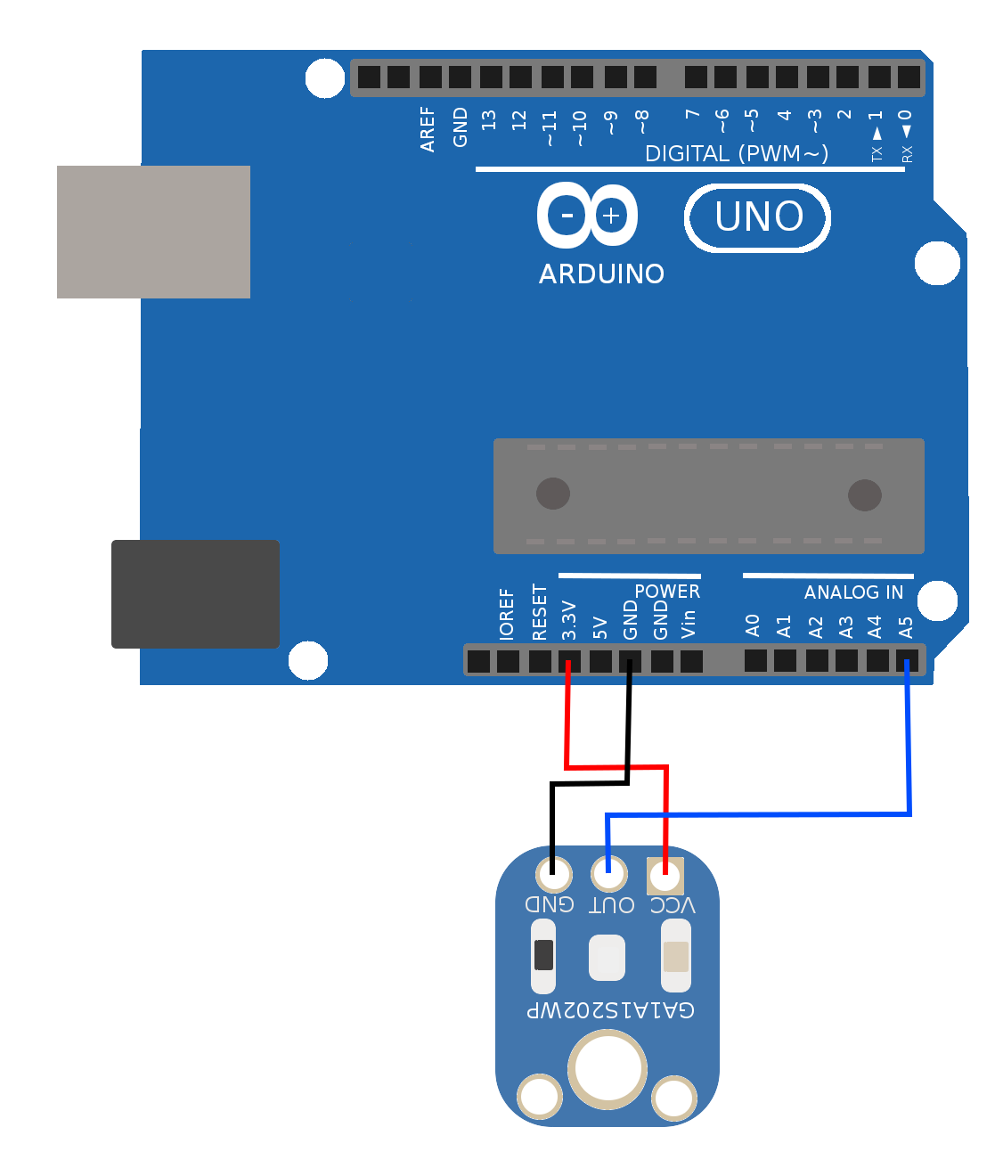

Keep in mind, this image is a schematic. Your implementation of this schematic will use the breadboard and so the wires will not all connect directly to the Arduino.

Testing
With the wiring complete, open the included sketch called 'Light Sensor.' Upload that sketch, and you should see that a reading from the light sensor printed to the screen every second. Put your finger over the sensor and see that the number goes down. If it doesn't, you might need to double-check your wiring.
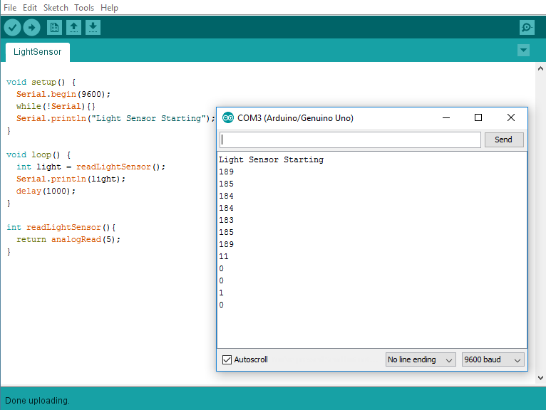
Code Walk Through

void setup() {
Serial.begin(9600);
while(!Serial){}
Serial.println("Light Sensor Starting");
}
Here we set up the serial connection, wait for it to be ready, and give a brief statement showing we're starting the light sensor sketch.
void loop() {
int light = readLightSensor();
Serial.println(light);
delay(1000);
}
Here we create a new variable of type integer, which we call light, and we assign a value using a function called readLightSensor. We wait for 1000 milliseconds (1 second) before repeating the process.
int readLightSensor(){
return analogRead(5);
}

Here we have a function that encapsulates the reading of the light sensor. This contains the information that the sensor is attached to analog pin 5; and abstracts away that information so we don't need to know it in the future when we make calls to this function.

